A project Report on

## WANDERLUST: A PERSONALIZED TRAVEL PLANNING AND TRACKING APP

BACHLOR OF COMPUTER APPLICATION

Devanga Arts College,

(Affiliated to Madurai Kamaraj University)

Aruppukottai-626101.

Submitted

By

**G.ARAVINDHASAMY (Reg No:C0S41802)**

**V.SASI KUMAR (Reg No:C0S41820)**

**S.PAVITHRA (Reg No:C0S41801)**

**B.GANESHRAJA (Reg No:C0S41807)**

Under the Guidence of

Mr. V.GNANASEKARAN M.Sc.,

Devanga Arts College

(Affiliated to Madurai Kamaraj University)

Aruppukottai-626101

**Introduction:**

Google today is launching a new mobile application, aimed at helping you better plan your vacations and other travels. Called Google Trips, the iOS and Android app pulls in a combination of data from Google Maps and crowdsourced contributions from other travelers, in order to offer a personalized travel guide that helps you keep track of your day trips, reservations, points of interest, tourist attractions, restaurants and more.

We already knew Google was working on a travel application, thanks to a leak earlier this year when the app was being tested within Google’s Local Guides community. Local Guides help to improve Google Maps and business data by writing reviews, correcting listings, and taking photos. In return, they gain exclusive access to try out new Google products and features, such as Google Trips.

The app looks today much like it did then.

The home screen includes a search box with a prompt “where do you want to go?” for planning new trips, and other cards let you keep track of your current and upcoming vacations and plans.

**Overview:**

**Software has changed how people travel, where they travel, when they travel, and even how they share their travels with others. It has also allowed for the democratization of travel, enabling travelers to easily book flights, hotels, and adventure tours. With the addition of new technology, travel has become more comfortable, providing travelers with the opportunity to access the Internet in-flight, book travel accommodations in advance, and see reviews of restaurants and tourist attractions.**

EMPATHY MAP



IDEATION & BRAINSTROMING MAP

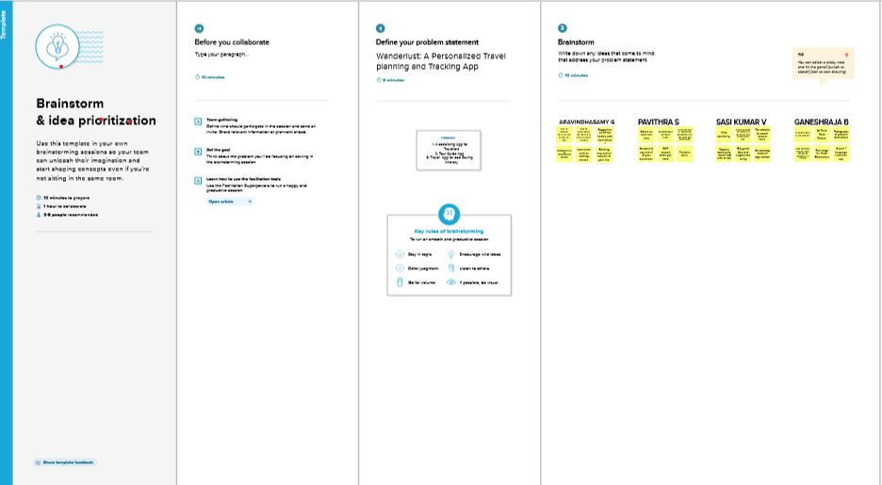

GROUP IDEAS

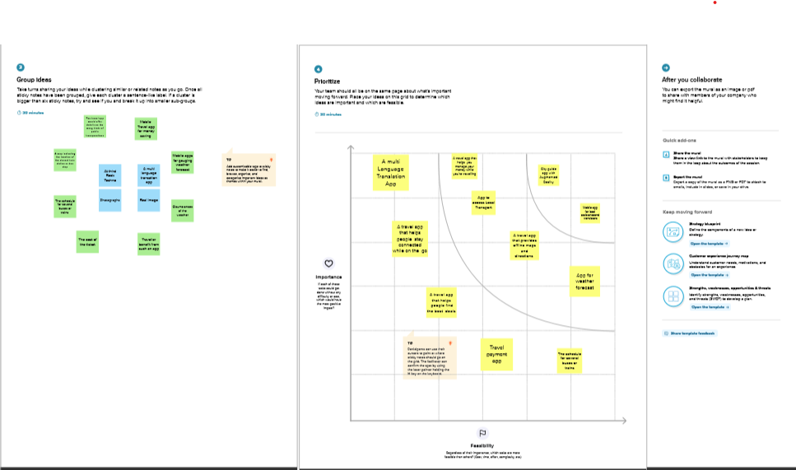

PRIORITIZE

RESULT

Login Page :















.

ADVANTAGES & DISADVANTAGES

A project built using the Android Compose UI toolkit. It demonstrates how to create a simple travel app using the Compose libraries. It also features a personalized feed of recommended accommodations based on the locations.

ADVANTATAGE

1.Communicate when it matters most

Quickly understanding the after-effect that the crisis might have on your people, organisation and assets is critical. Using an employee’s reallocation, your organisation can quickly locate and communicate with those impacted.

Relying on one sole channel for communication may not suffice in times of crisis. Due to overloaded cellular networks or internet outages, it is important to adopt various modes of communication from email, SMS, app notifications or text-to-speech.

2. Improves Safety and Security

Your Duty of Care is to the safety and security of your global workforce. Knowing where your employees are during a global security incident is vital. This will also help to facilitate support or potential evacuation should it be necessary.

Through an assistance app, your people can check in to proactively identify their location. Then tracking and monitoring allows your organisation to locate employees that may be impacted by a local incident. Your people impacted are then able to receive the required care and support.

3. Accelerate your Crisis Response

Should an incident occur, understanding the impact on your people and operations can be a time consuming and challenging task, especially when time is of the essence. With an effective crisis communications tool, a trigger will go off following a critical incident to identify which of your people are impacted. As a manager, you will be able to determine their safety with regular updates. As an organisation, you are prioritising the safety and security of your people, a critical part of an effective crisis management strategy.

DISADVANTAGES

1. Assuming always-on data connection.

It's not always on. Full stop.

Because it's mobile, users constantly lose coverage: metro/tube stations, inner buildings, car parkings, cathedrals (yes), rural areas.

And obviously, when it comes to traveling abroad, roaming forces data networks off for most users. Also let's not forget in-flight situations, where data is off and you'd still need to access data in your apps.

The fact is that as soon as coverage is lost, some apps stop working.

2. Assuming high speed network access.

Despite what you can read on theoretical data speeds, truth is mobile bandwidth is far from fast and predictable.

Tons of factors can influence the actual speed, such as number of people in the area, architectural structures of nearby buildings, weather conditions, and even the position of the hand on the device.

It's a good thing that our phones can transmit faster, but if everyone wants to transmit at the same time in a busy area, no one gets enough bandwidth and we must all keep retrying until everyone else is silent.

3. UX design too small and packed.

Some designers seem to forget that a finger is a finger. Every action button or dropdown list should be not only large enough that it can be hit with reasonable success, but also spaced away from other active items to avoid tapping the wrong one.

Selecting items in predictive search lists can be difficult if the results are too small and squeezed one next to the other.

**APPLICATIONS**

A myriad of tracking systems exists. Some are 'lag time' indicators, that is, the data is collected after an item has passed a point for example a bar choke point or gate.[1] Others are 'real-time' or 'near real-time' like Global Positioning Systems (GPS) depending on how often the data is refreshed. There are bar-code systems which require items to be scanned an auto-id). For the most part, the tracking worlds are composed of discrete hardware and software systems for different applications. That is, bar-code systems are separate from Electronic Product Cod (EPC) systems, GPS systems are separate from active real time locating systems

or RTLS for example, a passive RFID system would be used in a warehouse to scan the boxes as they are loaded on a truck - then the truck itself is tracked on a different system using GPS with its own features and software.[2 The major technology “silos” in the supply chain are: Distribution /warehousing /manufacturing Indoors assets are tracked repetitively reading e.g. a barcode,[3] any passive and active and feeding read data into Work in Progress models (WIP) or Warehouse Management Systems (WMS) or ERP software. The readers required per choke point are meshed auto-ID or hand-held ID applications. However tracking could also be capable of providing monitoring data without binding to a fixed location by using a cooperative tracking capability, e.g. an RTLS. Yard management Outdoors mobile assets of high value are tracked by choke point,[4] 802.11, Received Signal Strength Indication (RSSI), Time Delay on Arrival (TDOA), active RFID or GPS Yard Management; feeding into either third party yard management software from the provider or to an existing system. Yard Management Systems (YMS) couple location data collected by RFID and GPS systems to help supply chain managers to optimize utilization of yard assets such as trailers and dock doors. YMS systems can use either active or passive RFID tags. Fleet management Fleet management is applied as a tracking application using GPS and composing tracks from subsequent vehicle's positions. Each vehicle to be tracked is equipped with a GPS receiver and relays the obtained coordinates via cellularor satellite networks to a home station.[5] Fleet management is required by: • Large fleet operators, (vehicle/railcars/trucking/shipping) • Forwarding operators (containers, machines, heavy cargo, valuable shippings) • Operators who have high equipment and/or cargo/product costs • Operators who have a dynamic workload Person tracking See also: Real-time locating system Targeted surveillanceCell phone surveillance and Digital contact tracing Person tracking relies on unique identifiers that are temporarily (RFID tags) or permanently assigned to persons like personal identifiers (including biometric identifiers), or national identification numbers and a way to sample their positions, either on short temporal scales as through GPS or for public administration to keep track of a state's citizens or temporary residents. The purposes for doing so are numerous, for example from welfare and public security to mass surveillance

CONCLUSION

It's no wonder that, the app development process is exhausting, and overwhelming also. There have been lots of steps and processes to follow, and many decision making mechanism are involved as well.

But, we have tried our best to cover multiple scenarios and possibilities you might encounter. There are still challenges that could be out of the box, but this guidebook will hopefully help you create the basic framework for the process as well as the application.

Geo Tracking Services

A vital goal for hitting the gold mine in travel app development comes from the successful integration of GPS based location services. After dropping at a certain destination the first thing that a tourist wants to check out is a hotel, cafe or a nearby local attraction. Your travel app should get a GPS lock, track your location and quickly fetch results. Mobile apps such as RunGo does a fine job of searching nearby locations for all kinds of services a tourist can avail while on a trip.

Weather or Climate Forecasting

A lot of tourists book their flights in haste not thinking about the ramifications that a climate change can bring on an unplanned journey. To prevent such calamities travel mobile app development companies should always integrate a real-time climate forecast. Just to alert the traveler of upcoming weather predictions, when they are creating their travel itinerary. To get an idea of what I am talking about, check out apps like AccuWeather, that displays weather reports for a vast number of locations all over the world. It let users check cloud formation patterns, wind speed, humidity and several other important factors before planning trips.

Travel Itinerary Generator

This is the most important feature demanded by travel enthusiasts or tourists. What makes it so special?

An efficient itinerary generator only asks the user to mention the locations that they want to visit and automatically creates a travel plan from it.

Take a look at services like TripHobo, that lets users add existing tourist attractions or even add custom landmarks to generate their trip plan accordingly. Implementing such complex algorithms is not easy. But if you want to make your travel app a successful, then ask your travel app developers to work on it right on!

APPENDIX

SOURCE CODE

LoginActivity



Packagecom.example.travel app

import android.content.Context

import android.content.Intent

import android.os.Bundle

import androidx.activity.ComponentActivity

import androidx.activity.compose.setContent

import androidx.compose.foundation.Image

import androidx.compose.foundation.background

import androidx.compose.foundation.layout.*

import androidx.compose.material.*

import androidx.compose.runtime.*

import androidx.compose.ui.Alignment

import androidx.compose.ui.Modifier

import androidx.compose.ui.graphics.Color

import androidx.compose.ui.layout.ContentScale

import androidx.compose.ui.res.painterResource

import androidx.compose.ui.text.font.FontFamily

import androidx.compose.ui.text.font.FontWeight

import androidx.compose.ui.text.input.PasswordVisualTransformation

import androidx.compose.ui.tooling.preview.Preview

import androidx.compose.ui.unit.dp

import androidx.compose.ui.unit.sp

import androidx.core.content.ContextCompat

class LoginActivity : ComponentActivity() {

private lateinit var databaseHelper: UserDatabaseHelper

override fun onCreate(savedInstanceState: Bundle?) {

super.onCreate(savedInstanceState)

databaseHelper = UserDatabaseHelper(this)

setContent {

LoginScreen(this, databaseHelper)

}

}

}

@Composable

fun LoginScreen(context: Context, databaseHelper: UserDatabaseHelper) {

var username by remember { mutableStateOf("") }

var password by remember { mutableStateOf("") }

var error by remember { mutableStateOf("") }

Column(

modifier = Modifier.fillMaxSize().background(Color.White),

horizontalAlignment = Alignment.CenterHorizontally,

verticalArrangement = Arrangement.Center

) {

Image(painterResource(id = R.drawable.trav), contentDescription = "")

Text(

fontSize = 36.sp,

fontWeight = FontWeight.ExtraBold,

fontFamily = FontFamily.Cursive,

text = "Login"

)

Spacer(modifier = Modifier.height(10.dp))

TextField(

value = username,

onValueChange = { username = it },

label = { Text("Username") },

modifier = Modifier.padding(10.dp)

.width(280.dp)

)

TextField(

value = password,

onValueChange = { password = it },

label = { Text("Password") },

visualTransformation = PasswordVisualTransformation(),

modifier = Modifier.padding(10.dp)

.width(280.dp)

)

if (error.isNotEmpty()) {

Text(

text = error,

color = MaterialTheme.colors.error,

modifier = Modifier.padding(vertical = 16.dp)

)

}

Button(

onClick = {

if (username.isNotEmpty() && password.isNotEmpty()) {

val user = databaseHelper.getUserByUsername(username)

if (user != null && user.password == password) {

error = "Successfully log in"

context.startActivity(

Intent(

context,

MainActivity::class.java

)

)

//onLoginSuccess()

}

else {

error = "Invalid username or password"

}

} else {

error = "Please fill all fields"

}

},

modifier = Modifier.padding(top = 16.dp)

) {

Text(text = "Login")

}

Row {

TextButton(onClick = {context.startActivity(

Intent(

context,

RegisterActivity::class.java

)

)}

)

{ Text(text = "Register") }

TextButton(onClick = {

})

{

Spacer(modifier = Modifier.width(60.dp))

Text(text = "Forget password?")

}

}

}

}

private fun startMainPage(context: Context) {

val intent = Intent(context, MainActivity::class.java)

ContextCompat.startActivity(context, intent, null)

}

RegisterActivity:



package com.example.travelapp

import android.content.Context

import android.content.Intent

import android.os.Bundle

import androidx.activity.ComponentActivity

import androidx.activity.compose.setContent

import androidx.compose.foundation.Image

import androidx.compose.foundation.background

import androidx.compose.foundation.layout.*

import androidx.compose.material.*

import androidx.compose.runtime.*

import androidx.compose.ui.Alignment

import androidx.compose.ui.Modifier

import androidx.compose.ui.graphics.Color

import androidx.compose.ui.layout.ContentScale

import androidx.compose.ui.res.painterResource

import androidx.compose.ui.text.font.FontFamily

import androidx.compose.ui.text.font.FontWeight

import androidx.compose.ui.text.input.PasswordVisualTransformation

import androidx.compose.ui.tooling.preview.Preview

import androidx.compose.ui.unit.dp

import androidx.compose.ui.unit.sp

import androidx.core.content.ContextCompat

class RegisterActivity : ComponentActivity() {

private lateinit var databaseHelper: UserDatabaseHelper

override fun onCreate(savedInstanceState: Bundle?) {

super.onCreate(savedInstanceState)

databaseHelper = UserDatabaseHelper(this)

setContent {

RegistrationScreen(this, databaseHelper)

}

}

}

@Composable

fun RegistrationScreen(context: Context, databaseHelper: UserDatabaseHelper) {

var username by remember { mutableStateOf("") }

var password by remember { mutableStateOf("") }

var email by remember { mutableStateOf("") }

var error by remember { mutableStateOf("") }

Column(

modifier = Modifier.fillMaxSize().background(Color.White),

horizontalAlignment = Alignment.CenterHorizontally,

verticalArrangement = Arrangement.Center

) {

Image(painterResource(id = R.drawable.tra), contentDescription = "")

Text(

fontSize = 36.sp,

fontWeight = FontWeight.ExtraBold,

fontFamily = FontFamily.Cursive,

text = "Register"

)

Spacer(modifier = Modifier.height(10.dp))

TextField(

value = username,

onValueChange = { username = it },

label = { Text("Username") },

modifier = Modifier

.padding(10.dp)

.width(280.dp)

)

TextField(

value = email,

onValueChange = { email = it },

label = { Text("Email") },

modifier = Modifier

.padding(10.dp)

.width(280.dp)

)

TextField(

value = password,

onValueChange = { password = it },

label = { Text("Password") },

visualTransformation = PasswordVisualTransformation(),

modifier = Modifier

.padding(10.dp)

.width(280.dp)

)

if (error.isNotEmpty()) {

Text(

text = error,

color = MaterialTheme.colors.error,

modifier = Modifier.padding(vertical = 16.dp)

)

}

Button(

onClick = {

if (username.isNotEmpty() && password.isNotEmpty() && email.isNotEmpty()) {

val user = User(

id = null,

firstName = username,

lastName = null,

email = email,

password = password

)

databaseHelper.insertUser(user)

error = "User registered successfully"

// Start LoginActivity using the current context

context.startActivity(

Intent(

context,

LoginActivity::class.java

)

)

} else {

error = "Please fill all fields"

}

},

modifier = Modifier.padding(top = 16.dp)

) {

Text(text = "Register")

}

Spacer(modifier = Modifier.width(10.dp))

Spacer(modifier = Modifier.height(10.dp))

Row() {

Text(

modifier = Modifier.padding(top = 14.dp), text = "Have an account?"

)

TextButton(onClick = {

context.startActivity(

Intent(

context,

LoginActivity::class.java

)

)

})

{

Spacer(modifier = Modifier.width(10.dp))

Text(text = "Log in")

}

}

}

}

private fun startLoginActivity(context: Context) {

val intent = Intent(context, LoginActivity::class.java)

ContextCompat.startActivity(context, intent, null)

} MainActivity:

**MainActivity:**



package com.example.travelapp

import android.content.Context

import android.content.Intent

import android.os.Bundle

import androidx.activity.ComponentActivity

import androidx.activity.compose.setContent

import androidx.compose.foundation.Image

import androidx.compose.foundation.clickable

import androidx.compose.foundation.layout.*

import androidx.compose.foundation.rememberScrollState

import androidx.compose.foundation.verticalScroll

import androidx.compose.material.Card

import androidx.compose.material.Text

import androidx.compose.runtime.Composable

import androidx.compose.ui.Alignment

import androidx.compose.ui.Modifier

import androidx.compose.ui.draw.scale

import androidx.compose.ui.graphics.Color

import androidx.compose.ui.res.painterResource

import androidx.compose.ui.res.stringResource

import androidx.compose.ui.text.font.FontFamily

import androidx.compose.ui.text.font.FontWeight

import androidx.compose.ui.text.style.TextAlign

import androidx.compose.ui.unit.dp

import androidx.compose.ui.unit.sp

class MainActivity : ComponentActivity() {

override fun onCreate(savedInstanceState: Bundle?) {

super.onCreate(savedInstanceState)

setContent {

TravelApp(this)

}

}

@Composable

fun TravelApp(context: Context) {

Column(

modifier = Modifier

.padding(20.dp)

.verticalScroll(rememberScrollState())

) {

Text(

fontSize = 40.sp,

color = Color(android.graphics.Color.rgb(120, 40, 251)),

fontFamily = FontFamily.Cursive,

text = "Wanderlust Travel"

)

Spacer(modifier = Modifier.height(20.dp))

// 01

Card(

modifier = Modifier

.fillMaxWidth()

.height(250.dp)

.clickable {

context.startActivity(

Intent(context, BaliActivity::class.java)

)

},

elevation = 8.dp

)

{

Column(

horizontalAlignment = Alignment.CenterHorizontally

) {

Image(

painterResource(id = R.drawable.bali), contentDescription = "",

modifier = Modifier

.height(150.dp)

.scale(scaleX = 1.2F, scaleY = 1F)

)

Text(

text = stringResource(id = R.string.place_1),

fontSize = 18.sp

)

Text(

text = stringResource(id = R.string.description),

fontWeight = FontWeight.Light,

fontSize = 16.sp,

textAlign = TextAlign.Center,

)

Text(

text = stringResource(id = R.string.plan), color = Color.Gray,

fontSize = 16.sp

)

}

}

Spacer(modifier = Modifier.height(20.dp))

//02

Card(

modifier = Modifier

.fillMaxWidth()

.height(250.dp)

.clickable {

context.startActivity(

Intent(context, ParisActivity::class.java)

)

},

elevation = 8.dp

)

{

Column(

horizontalAlignment = Alignment.CenterHorizontally

) {

Image(

painterResource(id = R.drawable.paris), contentDescription = "",

modifier = Modifier

.height(150.dp)

.scale(scaleX = 1.2F, scaleY = 1F)

)

Text(

text = stringResource(id = R.string.place_2),

fontSize = 18.sp

)

Text(

text = stringResource(id = R.string.description),

fontWeight = FontWeight.Light,

fontSize = 16.sp,

textAlign = TextAlign.Center,

)

Text(

text = stringResource(id = R.string.plan), color = Color.Gray,

fontSize = 16.sp

)

}

}

Spacer(modifier = Modifier.height(20.dp))

//03

Card(

modifier = Modifier

.fillMaxWidth()

.height(250.dp)

.clickable {

context.startActivity(

Intent(context, SingaporeActivity::class.java)

)

},

elevation = 8.dp

)

{

Column(

horizontalAlignment = Alignment.CenterHorizontally

) {

Image(

painterResource(id = R.drawable.singapore), contentDescription = "",

modifier = Modifier

.height(150.dp)

.scale(scaleX = 1.2F, scaleY = 1F)

)

Text(

text = stringResource(id = R.string.place_3),

fontSize = 18.sp

)

Text(

text = stringResource(id = R.string.description),

fontWeight = FontWeight.Light,

fontSize = 16.sp,

textAlign = TextAlign.Center,

)

Text(

text = stringResource(id = R.string.plan), color = Color.Gray,

fontSize = 16.sp

)

}

}

Spacer(modifier = Modifier.height(20.dp))

}

}

}

CONCLUSION

The global pandemic brought the world to a standstill. Various sectors faced the brunt of it, especially the travel and tourism industry. The travel and tourism sector suffered a loss of $4.5 trillion in 2020 and the global GDP fell to 5.5%. As countries began easing travel restrictions, it became important travel websites and apps caught up with the new trends. People became wary of health regulations, therefore travel planner apps and websites had to work closely with their booking agents and policy advisories to guarantee that hotels and airlines were safe partners. There was a preference for traveling in smaller groups, such as with their families or close friends rather than tour groups. Individual bookings and smaller group tours were more popular due to the safety assurance they provided. Another major shift in traveling habits was that there was a demand for domestic travel over outbound travel due to the irregularity in country-wise travel regulations.

When it comes to convenience, logging in isn’t the only way to demonstrate it. The booking function, which combines flight tickets, train tickets, hotel reservations, and automobile reservations, will be the best feature in the travel planner app for users. Since all personal information is updated throughout the registration process, the ability to book with a single click will entice many users and travelers to download and utilize the app. A hassle-free reservation of various services through the convenience of a single app will add to the user experience.

FUTURE SCOPE

Easy Bookings

The obvious advantage that travel planner apps have is the convenience of making travel arrangements in an instant. It only requires the user to feed in the details about the dates of travel and choose the best airline or book the desired hotel room within no time. The speed at which technology has bridged the gap between information and access, allows one to make all their plans through a single app. Selecting a destination, purchasing tickets, reserving a hotel room at a reasonable rate, scheduling a cab for touring, discovering local attractions, and so on have become possible at the touch of a screen on a travel planning app.

Better Customer Support

One of the most significant benefits that mobile applications have provided to the tourism industry is the reduction of paperwork. You can save soft copies of hotel reservations, flight or train tickets, and other critical documents on your smartphone because it is convenient and portable. In light of any issues with such documents, quick access to customer service helps users to resolve their issues on the spot. Be it assistance in planning the trip or post-reservation feedback, the customer service provided by travel apps helps improve the experience of traveling. For example, if a customer has a problem reserving a ticket or a hotel, the support crew will be the first person they contact to resolve the issue. The simplicity with which the problem is resolved improves the user experience and popularizes your app.

SOURCE CODE